Ecommerce Business Models Explained
This is far from an exhaustive or comprehensive list, but this page illustrates some of the most common ecommerce business models and how they work.

Dropshipping Business Model
Basic idea: the seller is listing inventory for sale they don't actually own. They buy the inventory once a customer pays, and then ship it to the customer.
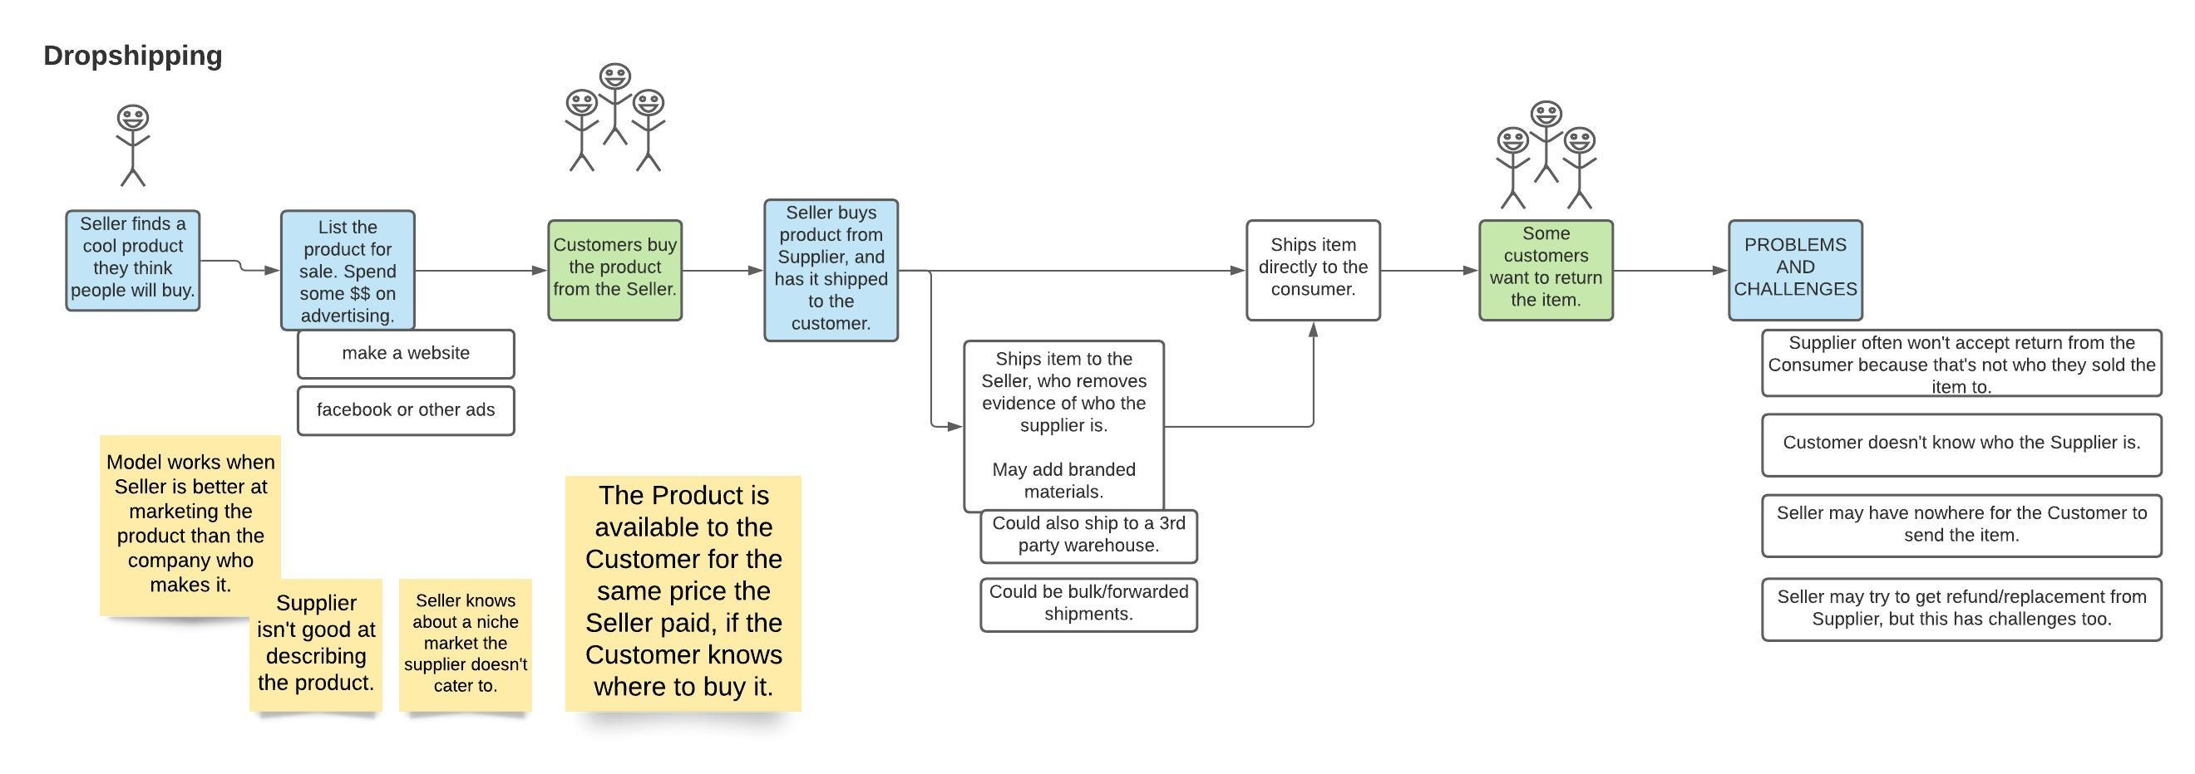ecommerce_business_models_-_dropshipping.jpeg

Arbitrage (aka OA or RA)
Basic idea: Seller buys inventory at a discount from a retailer or online store, and then sells it at a higher price somewhere else.
Many 3PLs charge extra or refuse to handle arbitrage. This article explains why.
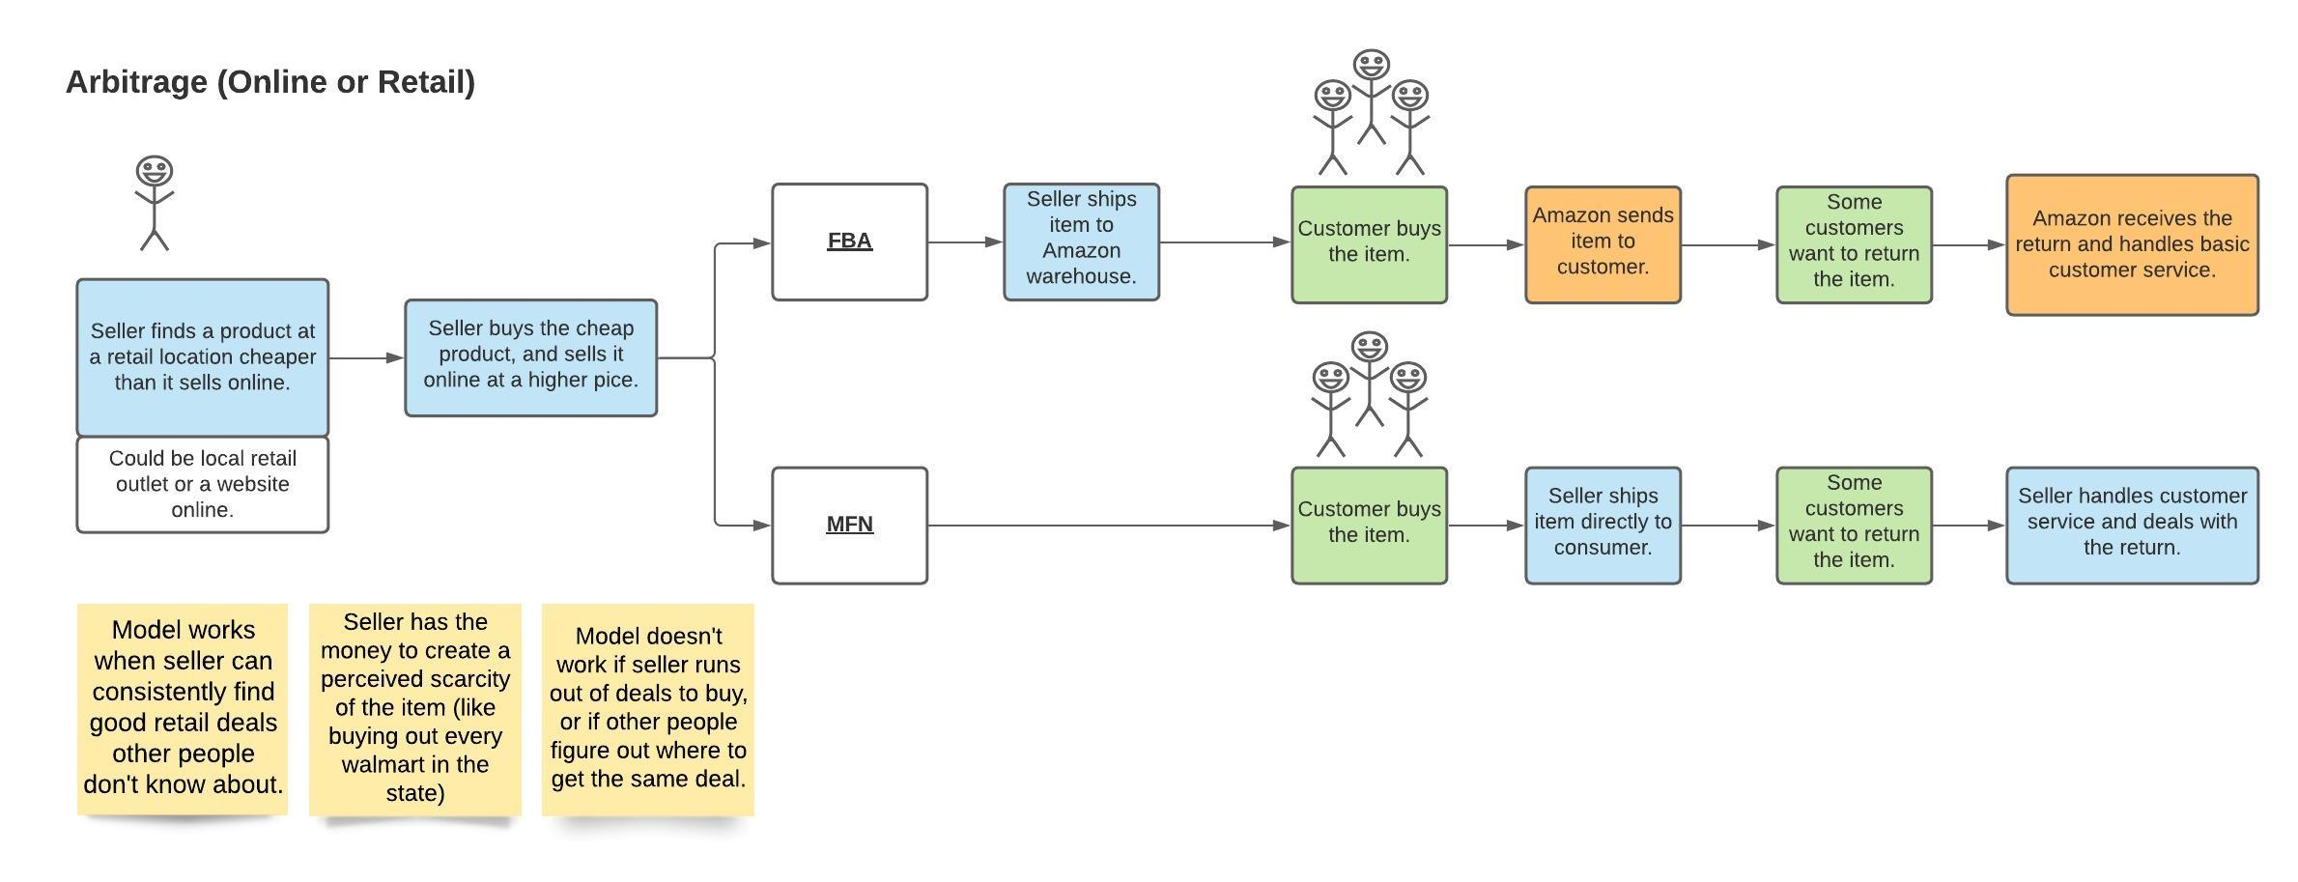ecommerce_business_models_-_arbitrage.jpeg

Wholesale
Basic idea: Seller negotiates a deal with a wholesaler, distributor, or manufactuer to purchase large quanitites of products in bulk at a discount. The seller then sells them online.
Wholesale can have certain advantages over private label, especially getting started.
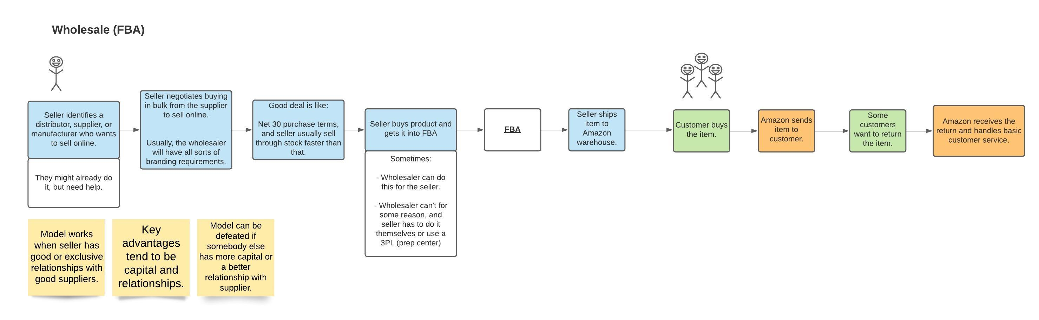ecommerce_business_models_-_wholesale.jpeg

Private Label
Basic idea: Seller invents their own product or innovates on someone else's. The seller then has it produced, markets it, and sells it online.
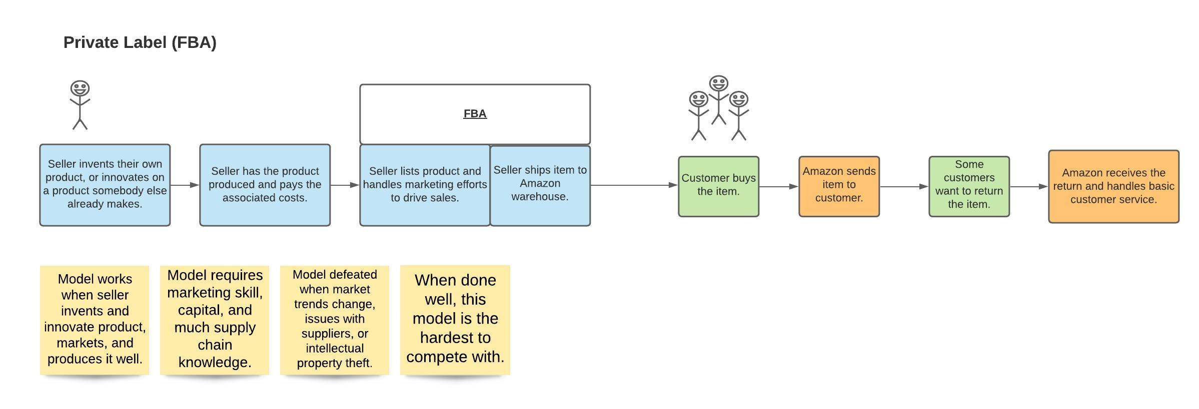ecommerce_business_models_-_private_label.jpeg

