Send to FBA from LDR
This guide covers how to send shipments into FBA from Logistics Done Right.

1. Create the Order in Seller Central
First, create the order(s) in Amazon Seller Central using the same workflow you would use to schedule other FBA shipments. Once you are finished, you will need to import these orders in LDR's web portal as described in the next step.

2. Download the SKU List for each order in Seller Central
Inside Amazon Seller Central you will need to download the “SKU List” for each of the orders shipping from LDR. You can find this by navigating to Inventory → Manage FBA Shipments inside Seller Central, or by going directly to your Shipping Queue with this link.
Inside your shipping queue, you will see the shipments you created, with a “Next Steps” column all the way on the right side of the screen.
If you click the arrow next to “Work on shipment” you will see the option to “Download SKU List”, as shown in the picture below.
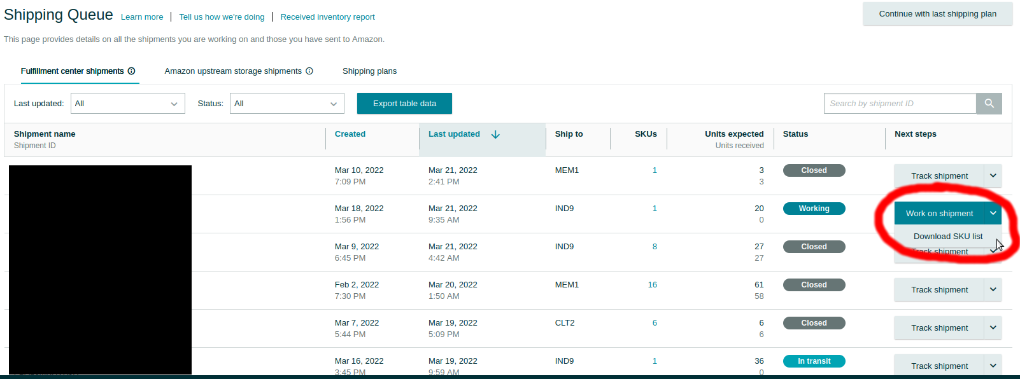
Click the “Download SKU List” option for each shipment that will be going to FBA from LDR, and save the files to your computer.

3. Import the shipments to the LDR web portal
Once you have downloaded the SKU lists from Amazon Seller Central you will need to import them to LDR's web portal. You can do that by navigating to Requests → FBA Checkout in the navigation bar or clicking this link.
You will see a page like the one below, where you can upload the SKU lists.
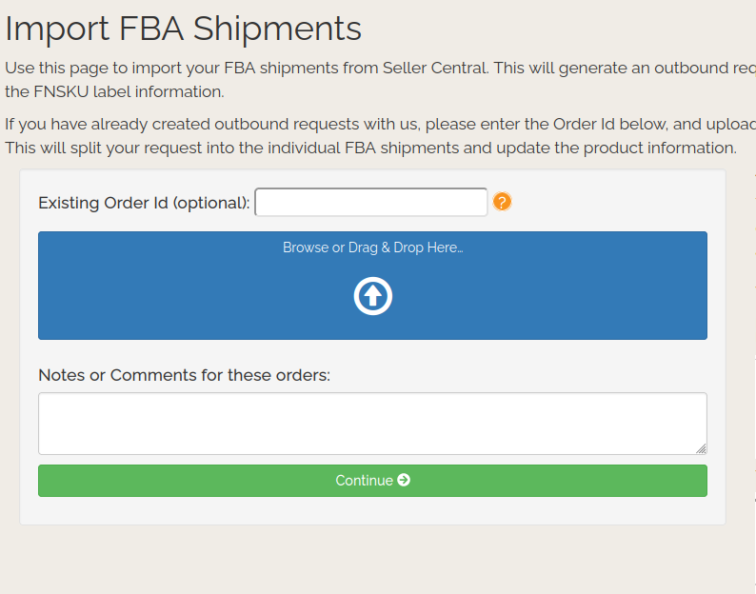
Simply upload the SKU lists and follow the onscreen prompts. This will create a corresponding outbound shipment(s) to LDR's web portal, with each Order Id matching your Seller Central FBA Shipping Queue.
This notifies our warehouse team about the orders so they can begin processing your FBA shipments. You do not need to provide or upload product FNSKU labels, as importing the SKU list does that for you.

4. Shipping
If you have setup Seller Central access with LDR, you don't need to do anything else. LDR will pick, prep, and pack your orders and arrange shipping using Amazon partnered carriers. You will notice the status of your order in LDR's web portal will update to “Outgoing” once it has shipped.
If you don't have Seller Central access setup with LDR, we recommend doing so. It typically speeds up processing by a day, and enables LDR to resolve many minor issues without needing to contact you.
If you haven't setup shared access you'll receive a notification email once your shipment is packed. You will need to use the packing information, weights, and dimensions included in the email to purchase shipping yourself from Amazon or another carrier. Once you have done that, you can follow the link in the email to upload the shipping labels to LDR.

