Inspection vs. Full Service: What's included?
Logistics Done Right Inc offers customizable levels of service for your removed or returned inventory. The conversation starts with the basic level of service you need: inspection or full service.
 |  | Inspection | Full Service
 | Check if factory seals are broken or other signs item was unboxed. | 
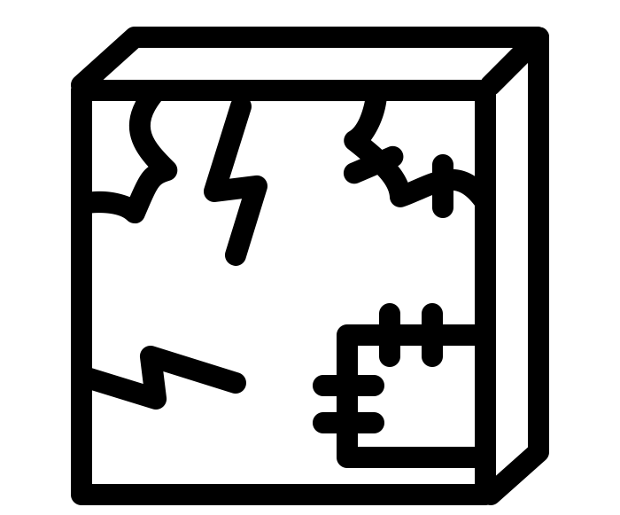 | Check for physical damage from shipping.
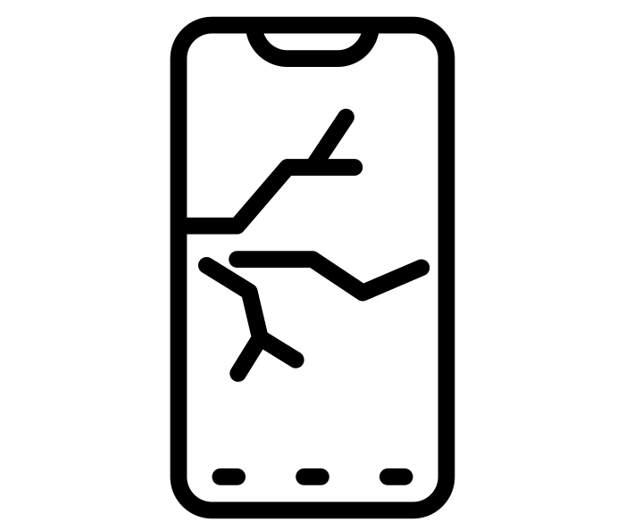 | Check items for scratches, dents, cracks, or stains.
 | Check for signs of fraud, and make sure the correct item was returned.
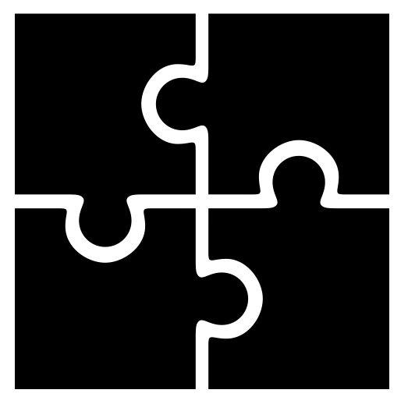 | Check for missing or damaged parts and components.
 | Basic cleaning, such as removing dust, fingerprints, or minor debris.*
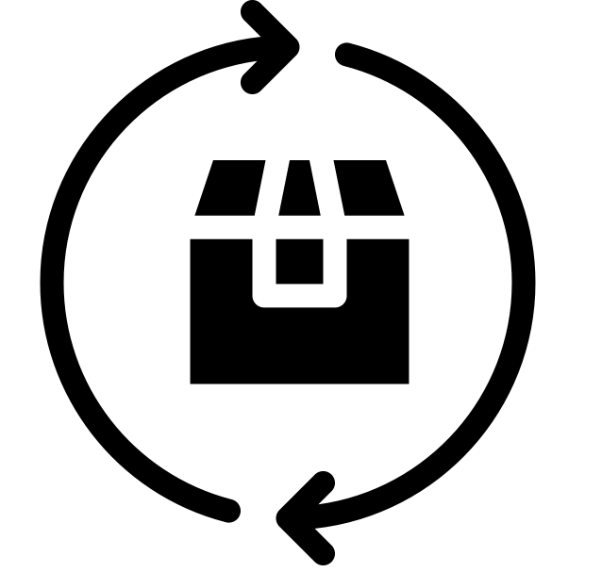 | Replace missing or damaged packaging, parts, components, or inserts.**
 | Check if the item powers on and works properly (where applicable).
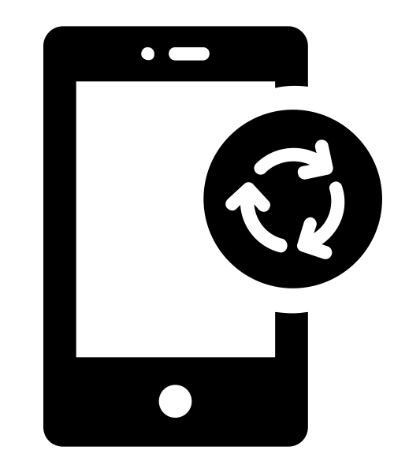 | Restore the item to factory default settings, or reinstall firmware (where applicable).

Which one do I need?
That depends on the products you sell and your supply chain. Here are some situations where each service makes a lot of sense.
Inspection is best if… | Full Service is best if…
Items are low-cost with very little resale value as used. | Your items are private label.
It's cheap and easy to recoup losses by claiming items with your supplier. | Your items are expensive, and have strong resale value as “used” or “refurbished” items.
You mainly need to verify the right item was returned in reasonable looking condition. | You are having bad reviews, but you aren't sure why.
 | You are experiencing quality issues or disputes with your supplier.

